**TOPIC: CELL: STRUCTURE AND FUNCTION**

**UNIT NO: B-05**

1. Unicellular microscopic organisms were first studied by

1. Robert Hooke 2. Preiestly 3. Pasteur 4. Leeuwenhoek

1. The figures of cork cells as seen by Robert HOOKE were published in the book

1. Origin of species 2. Species Plantarum 3. Genera plantarum 4. Micrographia

1. Match Column I with Column II and select the correct option from the codes given below

|  |  |  |  |
| --- | --- | --- | --- |
|  | **Column I** |  | **Column II** |
| A | Leeuwenhoek | i | First saw and described a living cell |
| B | Robert Brown | ii | Presence of cell wall is unique to plant cells |
| C | Schleiden | iii | Discovered the nucleus |
| D | Schwann | iv | All plants are composed of different kind of cells |

1. A – i, B – iii, C- iv, D- ii 2. A – i, B – iii, C- ii, D- iv

3. A – iii, B – i, C- iv, D- ii 4. A – i, B – iv, C- ii, D- iii

1. Omnis cellula e cellulae i.e., new cells arise from pre-existing cells, this statement was given by

1. Schleiden and Schwann 2. Rudolf Virchow 3. Robert Brown 4. Robert Hooke

1. Mesosomes are the infoldings of cell membrane, which

i. Are present in both prokaryotic and eukaryotic cells.

ii. Help in cell wall formation, DNA replication and respiration

iii. Increase the surface area of plasma membrane

1. i and ii 2. ii and iii 3. i and iii 4. i, ii and iii

1. _______ are self replicating, extra chromosomal segments of double stranded circular and naked DNA, present in a bacterial cell.

1. Plasmids 2. Nucleoid 3. Mesosomes 4. Bacteriophges

1. Read the given statements and select the correct option

Statement 1: In Prokaryotes mitochondria are absent

Statement 2: In prokaryotes mesosomes are present which help in respiration

1. Both statements 1 and 2 are correct and statement 2 is the correct explanation of statement 1

2. Both statements 1 and 2 are correct and statement 2 is not the correct explanation of statement 1

3. Statement 1 is correct and statement 2 is incorrect

4. Both statements 1 and 2 are incorrect

1. Which one is the mismatched pair?

1. Largest isolated cell – Egg of Ostrich 2. Golgi apparatus – Discovered by Altman

3. Mitochondria – Name was given by Benda 4. Lysosomes – Discovered by de Duve

1. Ribosomes are synthesised in

1. Nucleolus 2. Cytoplasm 3. Mitochondria 4. Golgi Complex

1. Read the given statements and select the correct option

Statement 1: The cisternae in Golgi complex have cis face and trans face

Statement 2: The cis face is also called forming face and trans face is also called maturing face

1. Both statements 1 and 2 are correct and statement 2 is the correct explanation of statement 1

2. Both statements 1 and 2 are correct and statement 2 is not the correct explanation of statement 1

3. Statement 1 is correct and statement 2 is incorrect

4. Both statements 1 and 2 are incorrect

1. As they release hydrolase that digest old and damaged cells, the term suicide bags is aptly used by cell biologists for

1. Golgi bodies 2. Lysosomes 3. Glyoxysomes 4. Peroxisomes

1. Match Column I with Column II and select the correct option from the codes given below

|  |  |  |  |
| --- | --- | --- | --- |
|  | Column I |  | Column II |
| A | Mitochondria | i | Without membrane |
| B | Lysosomes | ii | Single membrane |
| C | Ribosomes | iii | Double membrane |
| D | Nucleus |  |  |

1. A – i, B – ii, C- iii, D- iii

2. A – iii, B – i, C- i, D- ii

3. A – iii, B – ii, C- i, D- iii

4. A – ii, B – iii, C- i, D- iii

1. 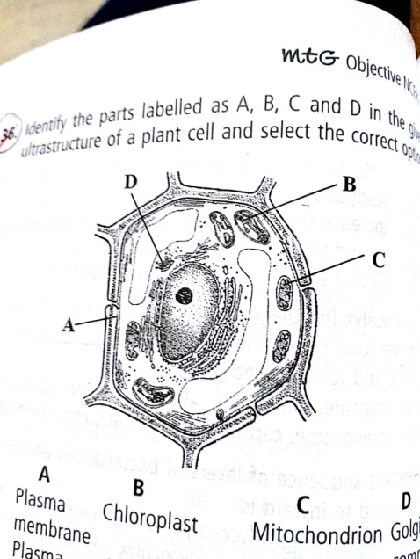Identify the parts labelled as A, B, C and D in the given ultra structure of a plant cell and select the correct option.

|  |  |  |  |  |
| --- | --- | --- | --- | --- |
|  | A | B | C | D |
| 1 | Plasma membrane | Chloroplast | Mitochondria | Golgi complex |
| 2 | Plasma membrane | Mitochondria | Chloroplast | RER |
| 3 | Cell wall | Mitochondria | Chloroplast | RER |
| 4 | Cell wall | Chloroplast | Mitochondria | Golgi complex |

1. Match Column I with Column II and select the correct option from the codes given below

|  |  |  |  |
| --- | --- | --- | --- |
|  | Column I |  | Column II |
| A | Dictyosomes | i | Storage |
| B | Mitochondria | ii | Photosynthesis |
| C | Vacuoles | iii | Transport |
| D | Grana | iv | Secretion |
|  |  | v | Respiration |

|  |  |  |  |  |
| --- | --- | --- | --- | --- |
|  | A | B | C | D |
| 1 | iv | v | i | ii |
| 2 | i | ii | iv | iii |
| 3 | iv | i | ii | iii |
| 4 | i | ii | iii | iv |

1. An elaborate network of filamentous proteinaceous structures present in the cytoplasm which helps in the maintenance of cell shape is called

1. Thylakoid 2. Endoplasmic reticulum 3. Plasmalemma 4. Cytoskeleton

1. Select the incorrect pair?

1. Cell wall – Structural support 2. Central vacuole – Storage

3. Amyloplast – Starch storage 4. Plasmodesmata – Protection



1. Non membrane bound cell organelle is

1. Ribosomes 2. Centrioles

3. Nucleolus 4. All of these

1. Select the option with correct labelling of given structure of Golgi apparatus

|  |  |  |  |  |
| --- | --- | --- | --- | --- |
|  | A | B | C | D |
| 1 | Cisternae | Vesicle | Trans face | cis face |
| 2 | Cisternae | Vesicle | cis face | Trans face |
| 3 | Vesicle | Cisternae | cis face | Trans face |
| 4 | Tubules | Vesicle | Trans face | cis face |

1. Study the following statements regarding mitochondria and select the correct ones

i. These are the sites of aerobic respiration

ii. Matrix contains single circular ds DNA molecule, a few RNA molecules, 70s ribosomes

iii. Mitochondria divide by fission

iv. Mitochondria are fully autonomous

1. i and ii 2. iii and iv 3. i, ii and iii 4. i, ii, iii and iii

1. Ribosomes of the cytoplasm, chloroplast and mitochondria are respectively

1. 80S, 80S and 70S 2. 80S, 70S and 70S 3. 70S in all 4. 80S in all

|  |  |  |  |
| --- | --- | --- | --- |
|  | Cristae | Cisternae | Thylakoids |
| 1 | iii | i | ii |
| 2 | i | ii | iii |
| 3 | ii | iii | i |
| 4 | iii | ii | i |

1. Read the given statements

i. Flat membranous sacs in stroma of chloroplast

ii. Infoldings in mitochondria.

iii. Disc shaped sacs in Golgi apparatus

Select the correct option as per the codes given in the table

1. _________ are granular structures first observed under electron microscope as dense particles by___________(1955)

1. Ribosomes, George Palade 2. Ribosomes, Perner

3. Lysosomes, de Duve 4. Peroxisomes, de Duve

1. Which of the following is correct for the given structure?

1. These are small structures which work like oars

2. It is covered with plasma membrane

3. Its core is called axoneme

4. All of these

1. Select the incorrect statement regarding the plasma membrane

1. Ratio of proteins and lipids varies considerably in different cell types

2. 52% proteins and 40% lipids constitute the membrane of human RBC

3. Arrangement of proteins (P) and Lipids (L) is L-P-P-P-L

4. Head of lipid is hydrophilic.

1. Read the given statements

i. Centromere is present in the middle of the chromosome and forms two equal arms

ii. Chromosome has a terminal Centromere

iii. Centromere lies close to the end of the chromosome forming one extremely short and one very long arm

iv. Centromere lies slightly away from the middle of the chromosome resulting into one shorter arm and one longer arm

Select the correct option as per the codes given above

|  |  |  |  |  |
| --- | --- | --- | --- | --- |
|  | Metacentric | SubMetacentric | Acrocentric | Telocentric |
| 1 | i | iv | iii | ii |
| 2 | i | ii | iii | iv |
| 3 | iv | i | iii | ii |
| 4 | iv | ii | iii | i |

1. Read the given statements and select the correct option

Statement 1: Peroxisomes are involved in photorespiration of the plant cells and help in the lipid metabolism of animal cells.

Statement 2: They are the cells garbage disposal system

1. Both statements 1 and 2 are correct and statement 2 is the correct explanation of statement 1

2. Both statements 1 and 2 are correct and statement 2 is not the correct explanation of statement 1

3. Statement 1 is correct and statement 2 is incorrect

4. Both statements 1 and 2 are incorrect

1. Read the given statements regarding a cell organelle

i. It contains water, sap, excretory products and other unwanted materials

ii. It i bounded by a single membrane called Tonoplast

iii. In plant cells, it can occupy up to 90% of cellular volume

iv. Its contents form cell sap. v. It maintains turgor pressure.

The above features are attributed to

1. Lysosome 2. Vacuole 3. Peroxisome 4. Motochondrion

1. Which of the following statements is incorrect

1. Mitochondria, unless specifically stained are not easily visible under the microscope

2. Physiological activity of cells determines the number of mitochondria per cell.

3. Mitochondrion, a power house of cell has DNA, RNA, ribosomes and enzymes and enzymes, so it can survive outside the cell.

4. Mitochondria divide by fission.

1. Match Column I with Column II and select the correct option from the codes given below

|  |  |  |  |
| --- | --- | --- | --- |
|  | Column I |  | Column II |
| A | Chloroplasts | i | Colourless plastids |
| B | Chromoplasts | ii | Yellow, orange or red coloured plastids |
| C | Leucoplasts | iii | Green plastids |

1. A – iii, B – i, C- ii 2. A – iii, B – ii, C- i 3. A – i, B – iii, C- ii 4. A – i, B – ii, C- iii

1. Which of the following represents the features of lysosomes?

1. A lower PH than the cytoplasm 2. Reduced hydrolase activity

3. Double membrane activity 4. All of these

.

1. Which of the following is the correct match?

1. Amyloplasts – Store carbohydrates 2. Elaioplasts – Store fats and oils

3. Aleuroplasts – Store proteins 4. All of these

1. The core of the cilium or flagellum compose of microtubules and their associated proteins is called

1. Blepharoplast 2. Axoneme 3. Microfilament 4. Tubulin

1. How does a cell rid itself of defective or malfunctioning organelles?

1. They are engulfed by plastids and stored until export from cell is possible

2. Defective parts accumulate until the cell itself dies

3. They are exported by exocytosis

4. Lysosomes assist in the removal of defective organelles by digesting them.

1. 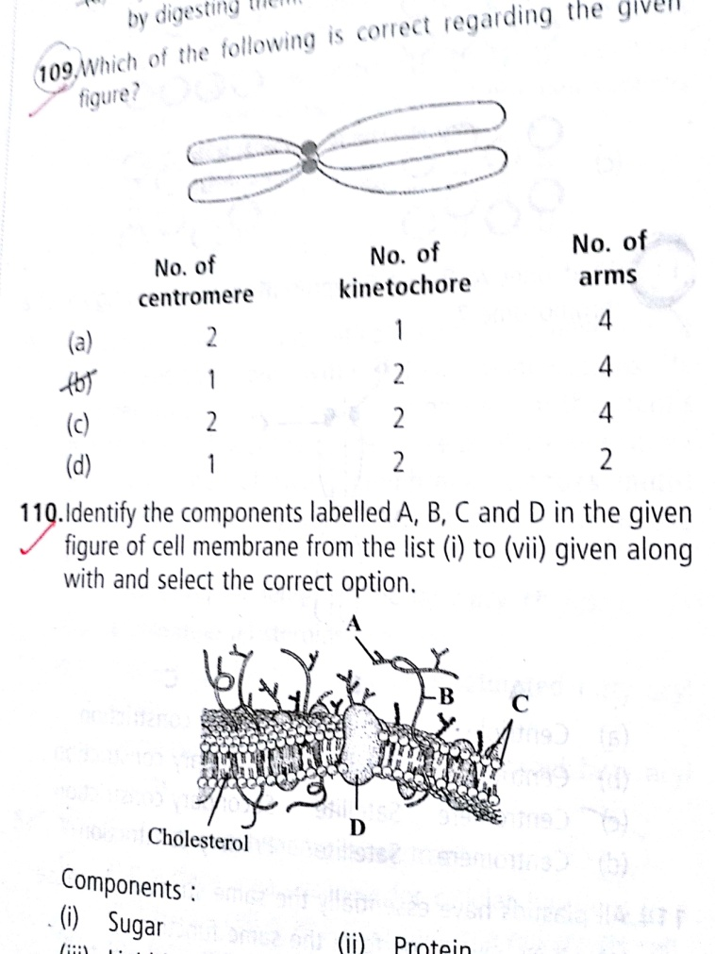Which of the following is correct regarding the given figure?

|  |  |  |  |
| --- | --- | --- | --- |
|  | **No. Of centromere** | **No. Of kinetochore** | **No. Of arms** |
| 1 | 2 | 1 | 4 |
| 2 | 1 | 2 | 4 |
| 3 | 2 | 2 | 4 |
| 4 | 1 | 2 | 2 |

1. Identify the components labelled A,B,C and D in the given figure of cell membrane from the list (i) to (vii) given along with and select the correct option.

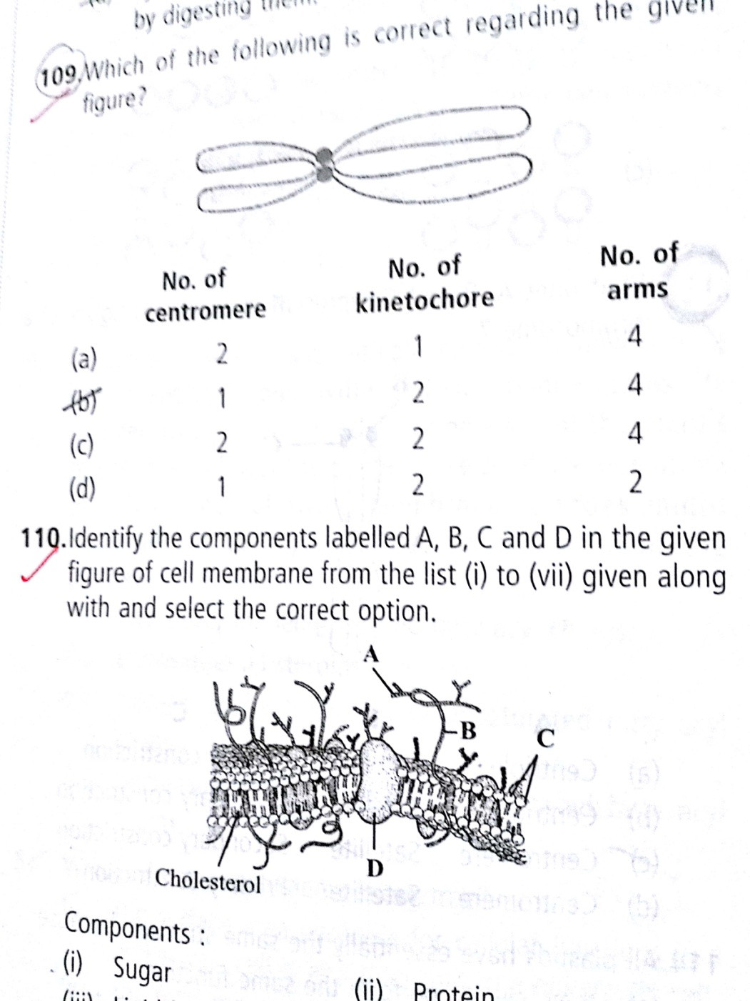**Components**:

i. Sugar, ii. Protein, iii. Lipid bilayer,

iv. Integral protein, v. Cytoplasm,

vi. Cell wall vii. External protein

1. A – i, B – ii, C- iii, D- iv

2. A – ii, B – i, C- iii, D- iv

3. A – i, B – ii, C- iii, D- vi

4. A – i, B – ii, C- iii, D- vii

1. A common characteristic feature of plant sieve tube cells and most of mammalian erythrocytes is

1. Absence of mitochondria 2. Presence of cell wall

3. Presence of haemoglobin 4. Absence of nucleus

1. In chloroplasts, chlorophyll is present in the

1. Outer membrane 2. Inner membrane 3. Thylakoids 4. Stroma

1. Select one which is not true for ribosomes.

1. Made of two sub units 2. Form polysome

3. May attach to mRNA 4. Have no role in protein synthesis

1. The lipid molecules present in plasma membrane have polar heads and non polar tails (as shown in figure). Which option represents the correct arrangement of lipids in lipid bilayer?

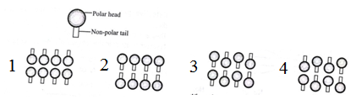

1. What does A, B and C represent in the given figure of a chromosome?

|  |  |  |  |
| --- | --- | --- | --- |
|  | **A** | **B** | **C** |
| (a) | Centriole | Satellite | Primary constriction |
| (b) | Centriole | Satellite | Secondary constriction |
| (c) | Centromere | Satellite | Secondary constriction |
| (d) | Centromere | Satellite | Primary constriction |

1. Which of these statements is / are true?

i. The surface area available for cellular functions in a prokaryotic cell is less than that in a eukaryotic cell.

ii. The total genome size of a prokaryotic cell is always less than that of a eukaryotic cell.

iii. Unlike eukaryotes, no special respiratory organelles are found in prokaryotes. Hence they respire at a much lesser rate than eukaryotes.

iv. Eukaryotic cells show various membrane bound organelles such as chloroplasts and nucleus while ribosomes are the only membrane bound organelles found in prokaryotes.

1. i and ii 2. iv only 3. iii only 4. i, ii and iv

1. Which one of these is not a eukaryote?

1. *Euglena* 2. *Anabaena* 3. *Spirogyra* 4. *Agaricus*

1. Different cells have different sizes. Arrange the following cells in an ascending order of their size and select the correct option.

i. Mycoplasma ii. Ostrich eggs iii. Human RBCs iv. Bacteria

1. i → iv → iii → ii 2. i → iii → iv → ii 3. ii → i → iii → iv 4. iii → ii → i → iv

1. Which of the following features is common to prokaryotes and many eukaryotes?

1. Chromatin material present 2. Cell wall present

3. Nuclear membrane present

4. Membrane bound subcellular organelles present

1. The stain used to visualise mitochondria is

1. Fast green 2. Safranin 3. Acetocarmine 4. Janus green

1. Which of the following stains is not used for staining chromosomes?

1. Basic Fuchsin 2. Safranin 3. Methylene green 4. Carmine

1. Which of the following options is true for a secretory cell?

1. Golgi apparatus is absent 2. RER is easily observed in the cell

3. Only SER is present 4. Secretory granules are performed in nucleus

1. Who proposed the fluid mosaic model of plasma membrane?

1. Camillo Golgi 2. Schleiden and Schwann

3. Singer and Nicolson 4. Robert Brown

1. Which of the following statements is not true for the cell membrane?

1. It is present in both plant and animal cells 2. Lipids are present in it as bilayer

3. Proteins may be peripheral or integral in it 4. Carbohydrates are never found in it

1. Plastids differ from mitochondria on the basis of which of the following features?

1. Presence of two layers of membrane 2. Presence of ribosome

3. Presence of thylakoids 4. Presence of DNA

1. Which of the following is not a function of cytoskeleton in a cell?

1. Intracellular transport 2. Maintenance of cell shape and structure

3. Support of the organelles 4. All the above

**Given below are assertion and reasons.**

**Point out if both are true with reason being correct explanation (A), both true but reason is not correct explanation (B), assertion true but reason is wrong (C), both are wrong (D).**

1. Assertion: The middle lamella is a layer made up of calcium pectate

Reason: It holds the different neighbouring cells together

1. A 2. B 3. C 4. D

1. Assertion: Mitochondria are called ‘Power houses’ of the cell

Reason: Mitochondria produce cellular energy in the form of ATP

1. A 2. B 3. C 4. D

1. Assertion: Interphase occupies 75 – 95% of the total generation time

Reason: Interphase (I-Phase) is the long non dividing phase

1. A 2. B 3. C 4. D

1. Assertion: Crossing over lead to recombination of genetic material on the two chromosomes

Reason: Crossing over is the exchange of genetic material between two homologous chromosomes

1. A 2. B 3. C 4. D

1. Which of the following is not true for a eukaryotic cell?

1. Cell wall is made up of peptidoglycans

2. It has 80s type of ribosome present in the cytoplasm

3. Mitochondria contain circular DNA

4. Membrane bound organelles are present

1. What is a tonoplast?

1. Outer membrane of mitochondria 2. Inner membrane of chloroplast

3. Membrane boundry of the vacuole of plant cells 4. Cell membrane of a plant cell

1. Given below is a schematic break-up of the phases/stages of cell cycle. Which one of the following is the correct indication of the stage/ phase in the cell cycle?

1. ‘A’ represents karyokinesis which is the division of cytoplasm

2. ‘B’ is telophase which is just reverse of prophase

3. ‘C’ is the best phase to count total number of chromosomes in any species

4. In ‘D’ stage, replication of DNA takes place on the template of the existing DNA

1. Meiosis in diploid organisms results in

1. Production of gametes 2. Reduction in the number of chromosomes

3. Introduction of variation 4. All of the above

1. At which stage of meiosis does the genetic constitution of gametes is finally decided?

1. Meaphase - I 2. Anaphase - II 3. Meaphase - II 4. Anaphase - I

1. Meiosis occurs in organisms during

1. Sexual reproduction 2. Vegetative reproduction

3. Both sexual and vegetative reproduction 4. None of these

1. During anaphase – I of meiosis

1. Homologous chromosomes separate 2. Non homologous chromosomes separate

3. Sister chromatids chromosomes separate 4. Non sister chromatids chromosomes separate

1. Meiosis is characterised by

1. Reduction division 2. Equal division

3. Both reduction and equal division 4. Pairing of homologous chromosomes

1. Which of the events listed below is not observed during mitosis?

1. Chromatin condensation 2. Movement of centrioles to opposite poles

3. Appearance of chromosomes with two chromatids joined together at the centromere

4. Crossing over

1. Identify the wrong statement about meiosis

1. Pairing of homologous chromosomes 2. Four haploid cells are formed

3. At the end of meiosis number of chromosomes are reduced to half

4. Two cycles of DNA replication occur

1. Cells which are not dividing are likely to be at

1. G1 2. G2 3. G0 4. S Phase

1. A bivalent of Meiosis – I consists of

1. Two chromatids and one centromere 2. Two chromatids and two centromere

3. Four chromatids and Two centromere 4. Four chromatids and Four centromere

1. Read the following statements about cell division and select the correct answer

i. M phase represents the phase when actual cell division occurs and I phase re[resents the phase between two successive M phases

ii. In the 24 hours average duration of cell cycle ofa human ell, cell division proper lasts for only about an hour.

iii. M phase constitutes more than 95% of the duration of cell cycle.

1. i and ii 2. ii and iii 3. i and iii 4. i, ii and iii

1. Select the correct statement about G1 phase

1. Cell is metabolically inactive 2. DNA in the cell does not replicate

3. It is not a phase of synthesis of macromolecules 4. Cell stops growing

1. 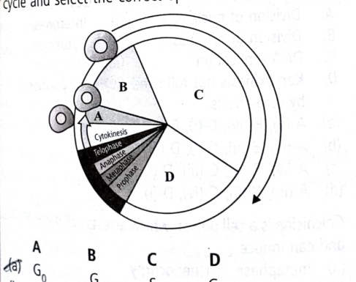Identify A, B, C and D in the given diagram depicting cell cycle and select the correct option

|  |  |  |  |  |
| --- | --- | --- | --- | --- |
|  | A | B | C | D |
| 1 | G0 | G1 | S | G2 |
| 2 | G1 | S | G2 | G0 |
| 3 | G1 | G0 | S | G2 |
| 4 | S | G0 | G1 | G2 |

1. Human cells in culture show a cell cycle to be completed in approximately

1. 42 hrs 2. 24hrs 3. 24mins 4. 24secs

1. Which one is the correct sequence of a cell cycle?

1. G2 → M → G1 → S 2. S → G2 → M → G1

3. G1→ S → G2 → M 4. M → G1 → S → G2

1. A cell cycle includes

1. Interphase and M-phase/ divisional phase 2. G1, S and G2 phase

3. Prophase, Metaphase, Anaphase and Telophase 4. Karyokinesis and cytokinesis

1. Centrioles undergo duplication during (i) of (ii) and begin to move towards opposite poles of the cell during (iii) stage of (iv)

|  |  |  |  |  |
| --- | --- | --- | --- | --- |
|  | (i) | (ii) | (iii) | (iv) |
| 1 | S Phase | Interphase | Prophase | Mitosis |
| 2 | S Phase | Interphase | Anaphase | Mitosis |
| 3 | Prophase | Mitosis | Metaphase | Mitosis |
| 4 | Prophase | Mitosis | Anaphase | Mitosis |

1. _______ is the best sage to count the number and study the morphology of chromosomes

1. Prophase 2. Metaphase 3. Anaphase. 4. Telophase

1. Mitotic spindle is mainly composed of ______ proteins

1. Tubulin 2. Myosin 3. Actin. 4. Actomyosin

1. During cell division, the spindle fibres get attached to condensing chromosome at a highly differentiated region, this region is called as

1. Chromomere 2. Chromocentre 3. Centriole 4. Kinetochore

1. Match Column I with Column II and select the correct option from the codes given below

|  |  |  |  |
| --- | --- | --- | --- |
|  | Column I |  | Column II |
| A | Division of nucleus | i | Interphase |
| B | Division of cytoplasm | ii | Cytokinesis |
| C | DNA replication | iii | Synchytium |
| D | Karyokinesis not followed by cytokinesis | iv | Karyokinesis |

1. A – ii, B – iv, C- i, D- iii

2. A – iv, B – ii, C- i, D- iii

3. A – iv, B – ii, C- iii, D- i

4. A – iii, B – ii, C- iv, D- i

1. Maximum chromosome number (630) in haploid cell is found in

1. Dog 2. Ophioglossum 3. Allium 4. Cat

1. Which phase of mitosis is essentially the reverse of prophase in terms of nuclear changes?

1. S-Phase 2. Anaphase 3. Telophase 4. Interphase

1. Cytokinesis in an animal cell takes place by ______ method in ______ direction, while in a plant cell it occurs by ______ method in _____ direction

1. Furrowing, Centrifugal, cell plate, centripetal

2. Furrowing, Centripetal, cell plate, centrifugal

3. Cell plate, Centrifugal, Furrowing, centripetal

4. Cell plate, Centripetal, Furrowing, centrifugal

1. 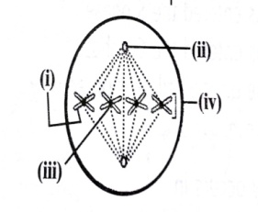Identify the structures indicated by labels (i), (ii), (iii) and (iv) and select the correct option

1. i – Chromatid, ii – Centiole, iii -Centromere, iv – Chromosome

2. i – Chromosome, ii – Centiole, iii - Centromere, iv – Chromatid

3. i–Chromatid, ii–Centromere, iii - Chromatid, iv – Chromosome

4. i – Chromosome, ii–Centromere, iii - Centriole, iv-Chromatid

1. 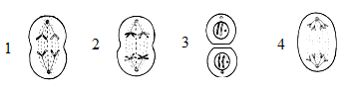In the sequence of figures given below, showing different stages of cell division, the missing stage (ii) is



1. Spindle formation can be disrupted by exposing cell to the microtubule poison such as

1. High concentration of oxygen 2. Vitamin A

3. Cholesterol 4. Colchicine

1. Chromosome duplication without nuclear division refers to

1. Meiosis 2. Mitosis 3. Androgenesis 4. Endomitosis

1. Select the correct option

|  |  |  |  |
| --- | --- | --- | --- |
|  | **Column I** |  | **Column II** |
| A | Chromosomes move to spindle equator | i | Anaphase – II |
| B | Centromere splits and chromatids apart | ii | Zygotene |
| C | Pairing between homologous chromosomes | iii | Pachytene |
| D | Crossing over between homologous chromosomes | iv | Anaphase I |

1. A – i, B – ii, C – iii, D – iv 2. A– ii, B– iii, C– iv, D– i

3. A – iv, B – i, C – ii, D– iii 4. A – iii, B – i, C– iv, D– ii

1. Crossing over in diploid organisms is responsible for

1. Dominance of genes 2. Linkage between genes

3. Segregation of alleles 4. Recombination of alleles

1. If 2n = 4, then identify the figures A, B and C as per the following codes and select the correct option

Anaphase of meiosis I = (i)

Anaphase of mitosis = (ii)

Anaphase of meiosis II = (iii)

1. A – ii, B – i, C – iii

2. A – iii, B – ii, C – i

3. A – i, B – ii, C – iii

4. A – (iii), B – (i), C – (ii)

1. An anther has 1200 pollen grains. How many PMCs must have been there to produce them?

1. 1200 2. 300 3. 150 4. 2400

1. Plasmodesmata are

1. Locomotory structures

2. Membranes connecting the nucleus with plasmalemma

3. Connection between adjacent cells 4. Lignified cemented layers between cells

**Topic: Cell: Unit of Life; Cell cycle and division**

**Unit: B-05**

**ANSWER KEY**

|  |  |  |  |  |  |  |  |  |  |
| --- | --- | --- | --- | --- | --- | --- | --- | --- | --- |
| **Q. No.** | **Ans.** | **Q. No.** | **Ans.** | **Q. No.** | **Ans.** | **Q. No.** | **Ans.** | **Q. No.** | **Ans.** |
| 1 | **4** | 2 | **4** | 3 | **1** | 4 | **2** | 5 | **2** |
| 6 | **1** | 7 | **2** | 8 | **2** | 9 | **1** | 10 | **2** |
| 11 | **2** | 12 | **3** | 13 | **1** | 14 | **1** | 15 | **4** |
| 16 | **4** | 17 | **4** | 18 | **1** | 19 | **3** | 20 | **2** |
| 21 | **3** | 22 | **1** | 23 | **4** | 24 | **3** | 25 | **1** |
| 26 | **3** | 27 | **2** | 28 | **3** | 29 | **2** | 30 | **1** |
| 31 | **4** | 32 | **2** | 33 | **4** | 34 | **2** | 35 | **1** |
| 36 | **4** | 37 | **3** | 38 | **4** | 39 | **2** | 40 | **3** |
| 41 | **1** | 42 | **2** | 43 | **1** | 44 | **2** | 45 | **4** |
| 46 | **3** | 47 | **2** | 48 | **3** | 49 | **4** | 50 | **3** |
| 51 | **4** | 52 | **2** | 53 | **1** | 54 | **1** | 55 | **3** |
| 56 | **1** | 57 | **3** | 58 | **4** | 59 | **4** | 60 | **4** |
| 61 | **1** | 62 | **1** | 63 | **1** | 64 | **4** | 62 | **4** |
| 66 | **3** | 67 | **3** | 68 | **4** | 69 | **2** | 70 | **1** |
| 71 | **2** | 72 | **3** | 73 | **1** | 74 | **1** | 75 | **2** |
| 76 | **1** | 77 | **4** | 78 | **2** | 79 | **2** | 80 | **3** |
| 81 | **1** | 82 | **1** | 83 | **1** | 84 | **4** | 85 | **4** |
| 86 | **3** | 87 | **4** | 88 | **1** | 89 | **2** | 90 | **3** |